Release Flow

What is Release Flow?
# Source: AI Source: Provided by: [Data Path: Persons Table -> ID Column: 1, Name_En Column: Motasem Essam] -> From: [ChatGPT] on [2/15/2026]
Release Flow is a workflow designed for long-lived projects that require formal release management.
Developers work on a main development line, but release branches are created to stabilize code before deployment. Hotfixes are applied directly to release branches and merged back into the main line.
This workflow is often used in large enterprise software projects where releases must be carefully managed and production stability is critical.

How It Works
# Source: AI Source: Provided by: [Data Path: Persons Table -> ID Column: 1, Name_En Column: Motasem Essam] -> From: [ChatGPT] on [2/15/2026]
- Developers work on the main development branch.
- When a release is planned, a release branch is created from the main branch.
- Only bug fixes, testing, and documentation updates are applied to the release branch.
- Once the release is ready:
  - It is deployed to production
  - Changes are merged back into the main branch
- Hotfix branches can be created from the release branch for urgent fixes, which are also merged back into the main branch.

Conceptual Visualization
# Source: AI Source: Provided by: [Data Path: Persons Table -> ID Column: 1, Name_En Column: Motasem Essam] -> From: [ChatGPT] on [2/15/2026]
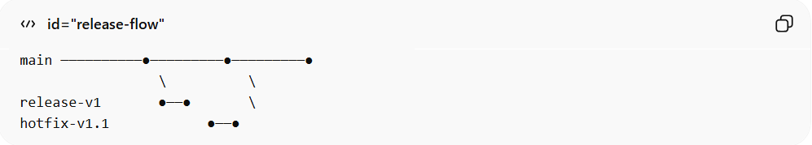
main ──────────●─────────●─────────●
\ \
release-v1 ●──● \
hotfix-v1.1 ●──●
- Main branch = ongoing development
- Release branches = stabilize and finalize releases
- Hotfix branches = urgent fixes

When It Is Used
# Source: AI Source: Provided by: [Data Path: Persons Table -> ID Column: 1, Name_En Column: Motasem Essam] -> From: [ChatGPT] on [2/15/2026]
- Large software projects with scheduled releases
- Enterprise applications or products with long release cycles
- Teams that need strict control over production stability
- Projects where hotfixes must be tracked separately

Advantages
# Source: AI Source: Provided by: [Data Path: Persons Table -> ID Column: 1, Name_En Column: Motasem Essam] -> From: [ChatGPT] on [2/15/2026]
- Strong control over releases
- Production stability is prioritized
- Bug fixes can be applied safely to releases
- Clear separation of development and release work

Disadvantages
# Source: AI Source: Provided by: [Data Path: Persons Table -> ID Column: 1, Name_En Column: Motasem Essam] -> From: [ChatGPT] on [2/15/2026]
- More complex than simple feature branch workflows
- Slower integration due to release branches
- Requires discipline and process management
- Not ideal for rapid continuous deployment

Key Idea (General Summary)
# Source: AI Source: Provided by: [Data Path: Persons Table -> ID Column: 1, Name_En Column: Motasem Essam] -> From: [ChatGPT] on [2/15/2026]
Release Flow = Main development branch + release branches + hotfixes → Controlled, stable releases
It is a structured workflow suitable for enterprise and long-lived software projects that need careful release management.

